

SCHOOL OF COMPUTING AND INFORMATICS
BIT3208 – ADVANCED WEB DESIGN AND DEVELOPMENT
LOGBOOK REPORT

Student Details
Student Name: HARRISON MUTUA
Admission Number: BSCCS/2024/54032_
Course: Bachelor of Computer Science
Unit Code: BIT3208
Unit Name: Advanced Web Design and Development
Lecturer Name: Mr Nyoro
Academic Year: 2026

Project Details
Project Title: BomaHomes Tenant and Landlord Management System
Technologies Used: STACK
- HTML
- PHP
- MySQL
- JavaScript
- XAMPP
- VS Code
GitHub link

TABLE OF CONTENT
Week 1
- Installation and Testing of Local Development Environment…………………………………………………………………………pg4
- Objectives…………………………………………………………………………….pg4
- Activities……………………………………………………………………………….pg4
- Student reflection…………………………………………………………………pg4
- Figures………………………………………………………………………………….pg4
- Installation of XAMPP……………………………………………pg5
- Apache and MySQL running……………………………………….pg5
- Localhost test page…………………………………………………….pg6
- Hello World test………………………………………………………….pg7
Week 2
- UI /UX and Design Foundations………………………………………………pg7
- Objectives………………………………………………………………………………pg7
- Activities…………………………………………………………………………………pg7
- Student Reflection……………………………………………………………………pg8
- Figures……………………………………………………………………………………pg8
- Registration Page Wireframe………………………………………….pg8
- Login Page Wireframe………………………………………………….pg9
- Dashboard Wireframe………………………………………………….pg10
- System workflow Diagram……………………………………………pg11
Week 3
- Frontend interactions and Backend Foundations……………………pg12
- Objectives………………………………………………………………………………pg12
- Activities…………………………………………………………………………………pg12
- Student reflection……………………………………………………………………pg12
- Figures……………………………………………………………………………………pg12
- JavaScript form validation………………………………………………pg13
- Password strength checker……………………………………………..pg13
- PHP Sytanx practice……………………………………………………….pg13
- Database connection script………………………………………….pg13
- Dynamic user input handling…………………………………………pg15

Week 4
- Authentication……………………………………………………..pg15
- Objectives………………………………………………………………pg15
- Activities…………………………………………………………………pg15
- Student reflection…………………………………………………..pg16
- Figures…………………………………………………………………….pg16
- User registration form………………………………….pg16
- Login form…………………………………………………….pg16
- Successful login dashboard……………………………pg17
- Session handling test…………………………………….pg17
Week 5
- Database integration and CRUD operations …………….pg18
- Objectives……………………………………………………………….pg18
- Activities ………………………………………………………………….pg18
- Student reflection………………………………………………………pg18
- Figures………………………………………………………………………pg19
- Tenant Registration Form………………………………..pg19
- Viewing Tenant Records……..……………………………pg20
- Updating Tenant Information………………………….pg21
- Deleting Tenant Records…………………………………pg22
- MySQL Database Tables………………………………….pg22

WEEK 1
Installation and Testing of Local Development Environment

Objectives
The objective of Week 1 was to install and configure the local web development environment required for developing the BomaHomes Tenant and Landlord Management System.
Activities
During this week, the following activities were completed:
- Installed XAMPP
- Started Apache and MySQL services
- Created the BomaHomes project folder in htdocs
- Tested localhost in the browser
- Created a simple HTML page
- Created a PHP Hello World page
- Tested database connection using PHP and MySQL

Student Reflection
During Week 1, I successfully configured the local development environment required for the BomaHomes system. XAMPP was installed and Apache together with MySQL services were tested successfully. PHP and MySQL database connectivity was also tested using mysql connect(). This week improved my understanding of local server configuration and backend environment setup for web application development.

Figures
Installation of XAMMP
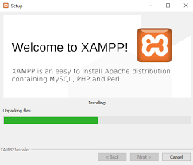
Fig 1.1 shows successful installation of XAMPP used for local web development

Apache and MySQL running
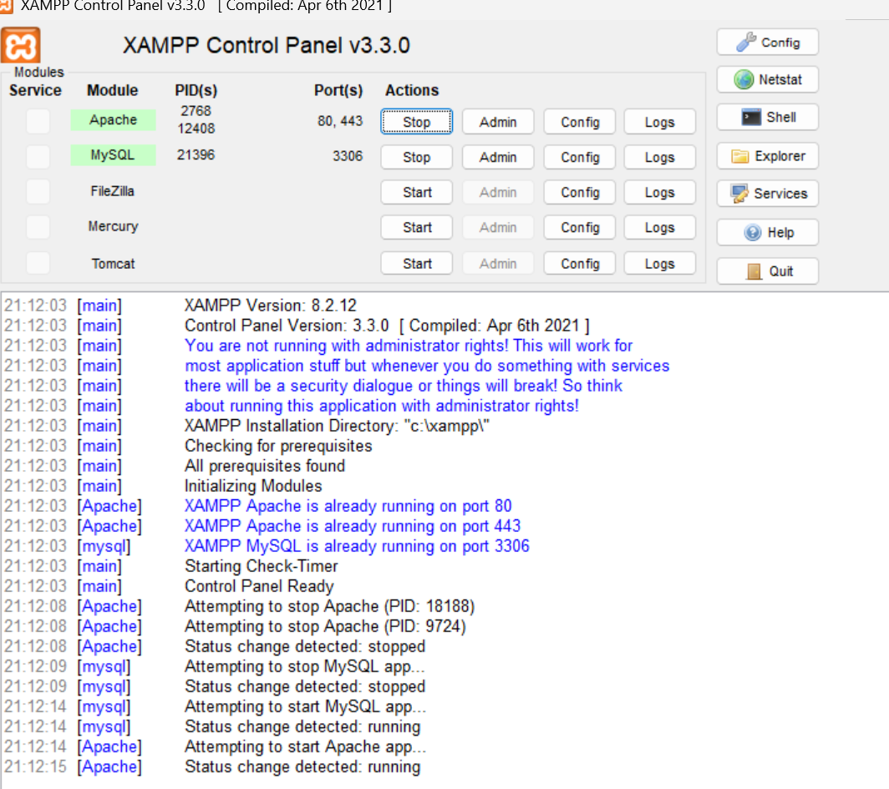
Fig1.2 shows Apache and MySQL services running successfully in the XAMPP Control Panel.

Localhost Test page
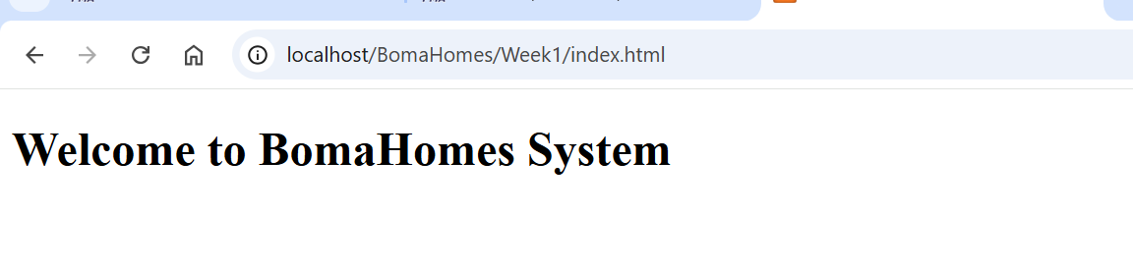
Fig1.3 shows localhost running successfully in the browser after configuring XAMPP.

Hello World test
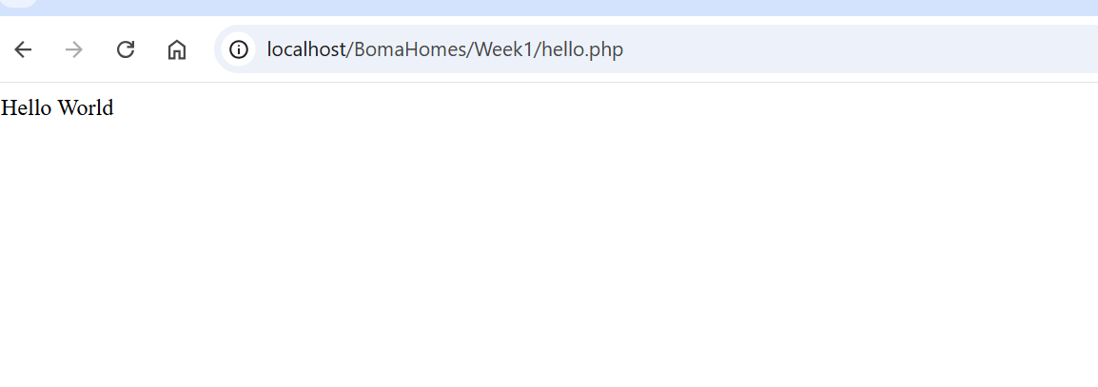
Fig1.4 shows successful execution of the first PHP test page

Week 2
UI/UX and Design Foundations

Objectives
To plan and design the BomaHomes Tenant and Landlord Management System before implementation by developing wireframes, designing the user interface, selecting development technologies, and defining the overall system workflow
Activities
- Selected the BomaHomes Tenant and Landlord Management System project.
- Planned the system structure and user interactions.
- Designed the registration page wireframe.
- Designed the login page wireframe.
- Designed the dashboard wireframe.
- Planned navigation between system pages.
- Selected the color scheme, forms and button styles.
- Designed the system workflow.
- Chose PHP, MySQL, HTML, CSS and JavaScript as development technologies.
- Prepared the project for implementation in subsequent weeks.
Student Reflection

Figures

Register Wireframe
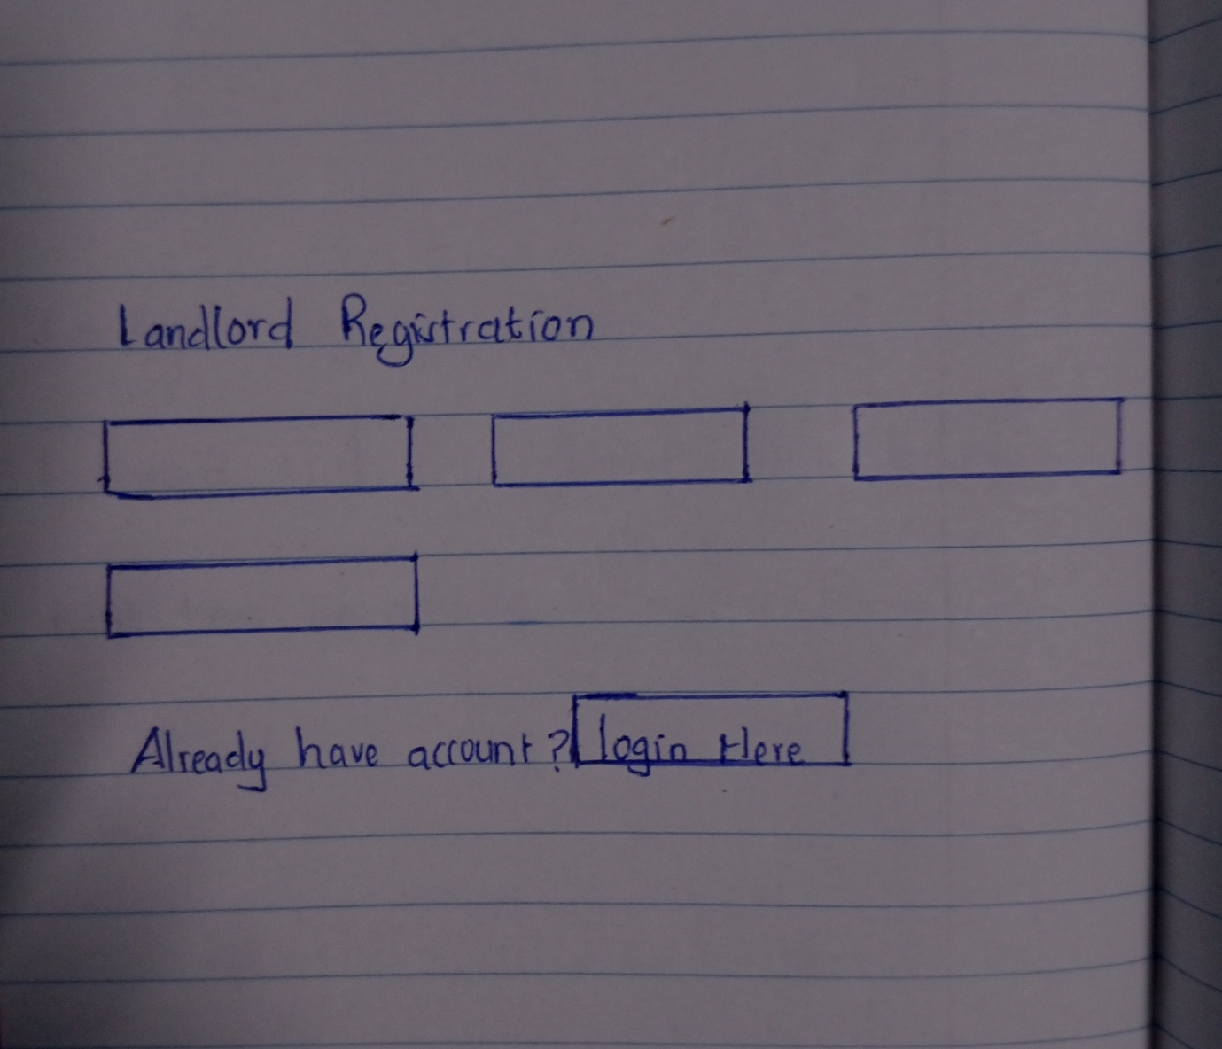
Fig2.1 showing registration wireframe for the landlord.
Login wireframe
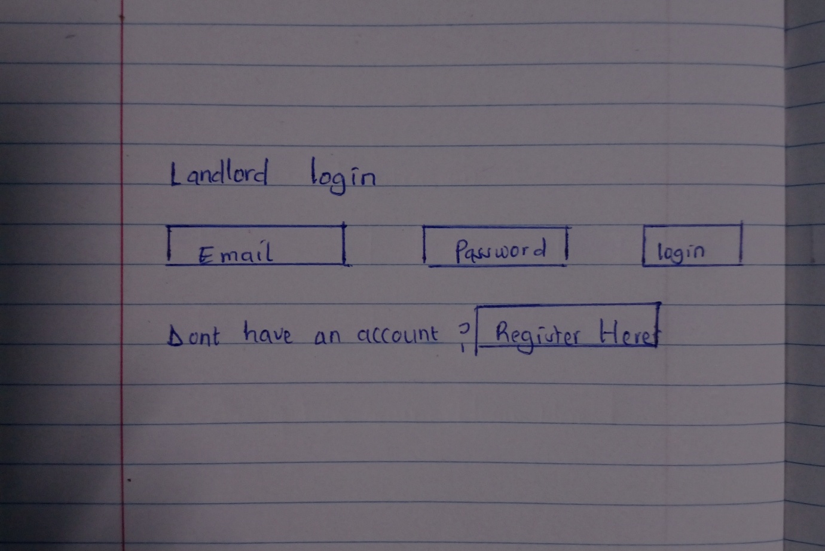
Fig 1.2 showing login layout

Dashboard Wireframe
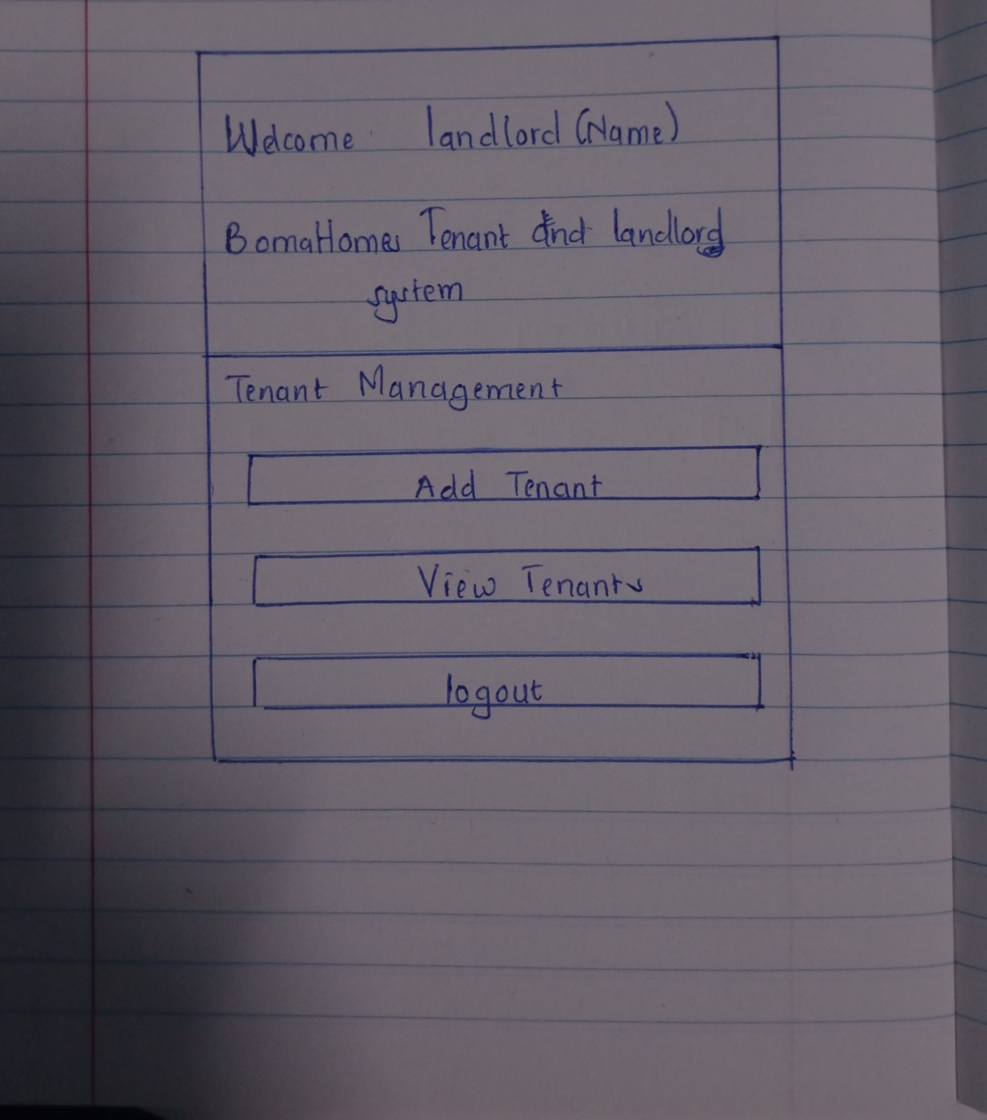
Fig2.3 showing how the system looks like

Workflow
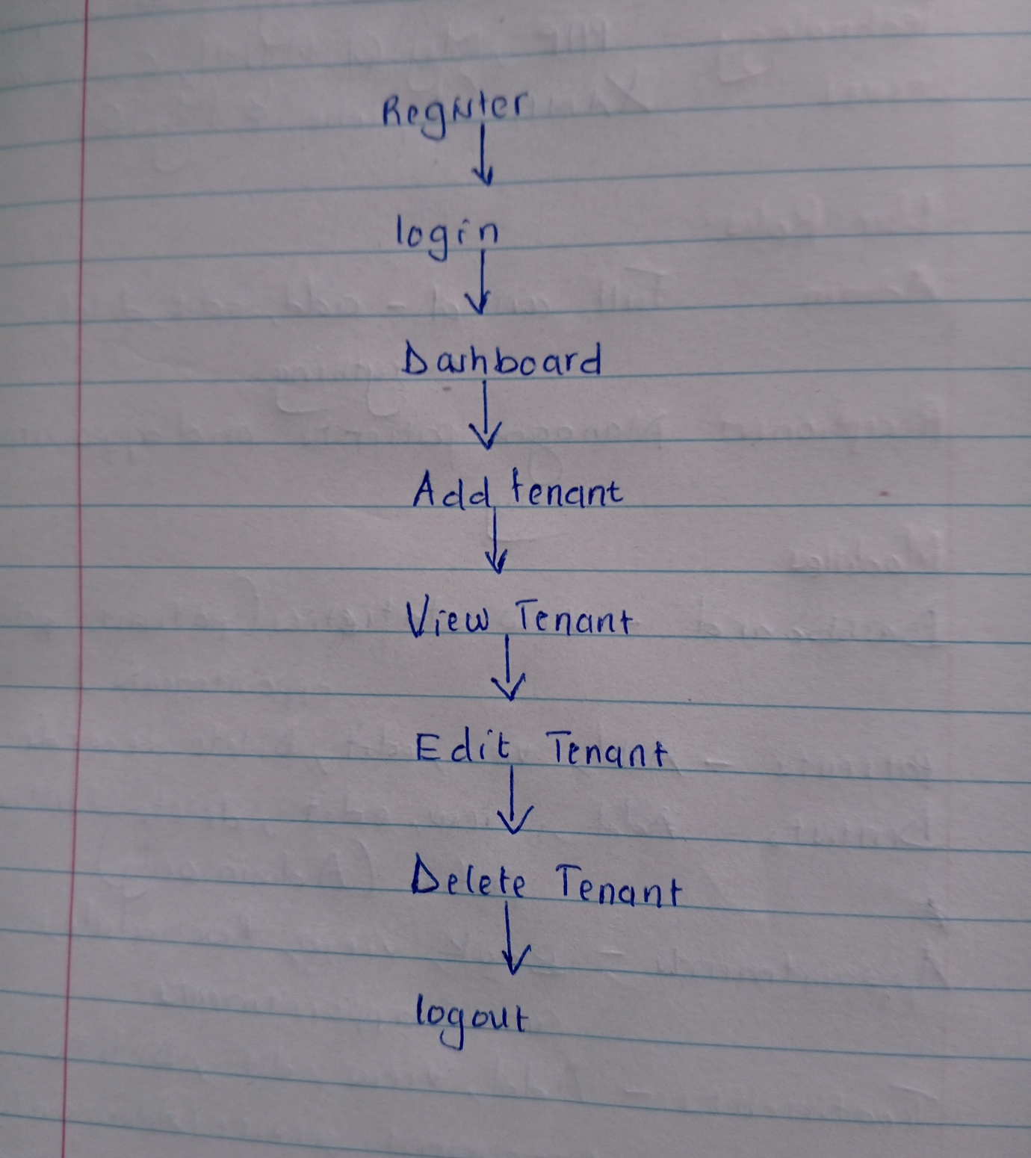
Fig 2.4 logic of the system

Week 3
Frontend Interactions and Backend foundations

Objectives
The objective of Week 3 was to introduce frontend scripting and backend processing concepts for the BomaHomes system.

Activities
During this week, the following activities were completed:
- Created JavaScript form validation
- Implemented password validation
- Practiced PHP syntax
- Tested form input handling
- Connected PHP to MySQL database
- Created dynamic form processing scripts
Student Reflection
During Week 3, I implemented frontend validation and backend processing features for the BomaHomes system. JavaScript improved user interaction by validating form input before submission, while PHP handled backend processing and database connectivity. This week improved my understanding of how frontend and backend technologies interact in dynamic web applications.

Figures

JavaScript form validation
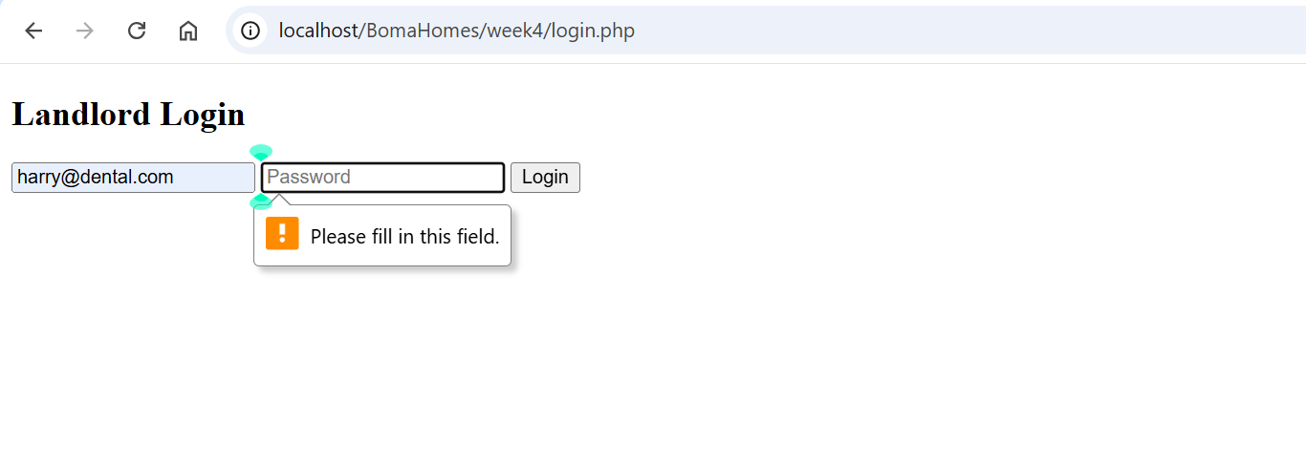
Fig3.1 shows JavaScript validation preventing empty form submission in the login page.

Password strength checker
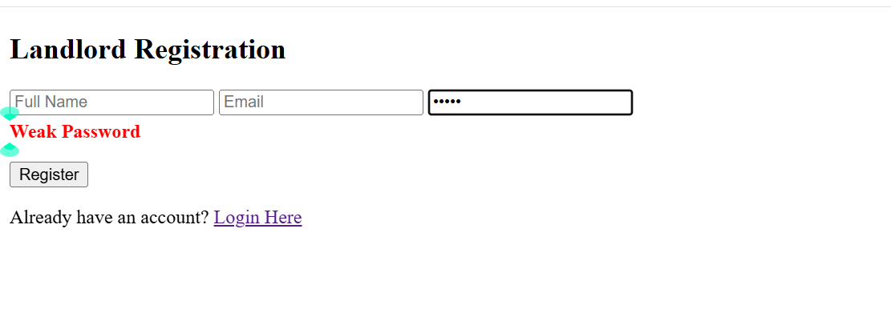
Fig3.2 shows password validation functionality implemented using JavaScript.

PHP Syntax practice
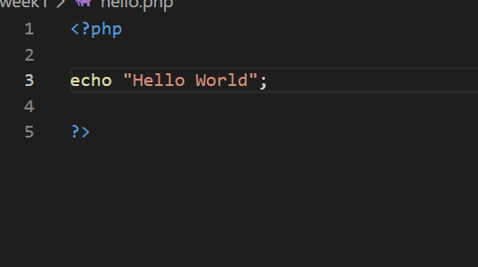
Fig3.3 shows successful execution of PHP syntax practice within the BomaHomes project.

Database Connection Script
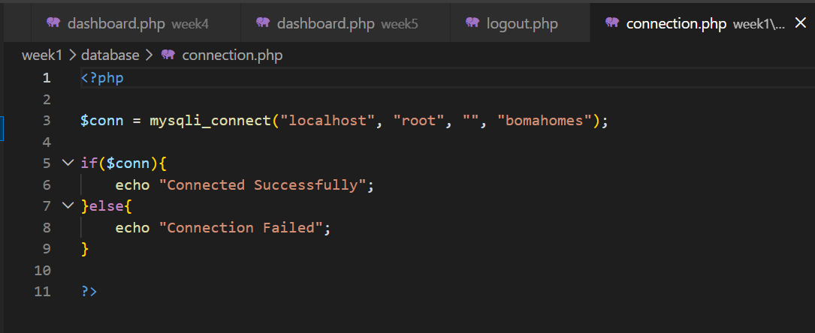

Fig3.4 shows successful connection between PHP and MySQL database using mysqli_connect().
Dynamic user input Handling
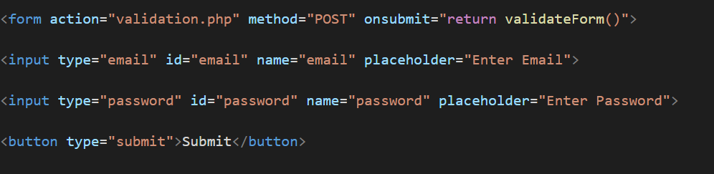
Fig3.5 shows PHP processing user input dynamically through HTML forms

Week 4
Authentication

Objectives
The objective of Week 4 was to implement backend authentication and session management for the BomaHomes system.
Activities
During this week, the following activities were completed:
- Created registration form
- Developed login form
- Implemented password hashing
- Tested login validation
- Implemented PHP sessions
- Created dashboard page
- Developed logout functionality

Student Reflection
During Week 4, I implemented the authentication system for the BomaHomes project. Users can now register and login securely using PHP sessions and password hashing. Session handling was used to restrict unauthorized dashboard access. This week improved my understanding of backend authentication and secure login implementation in web applications
Figures

User Registration Form
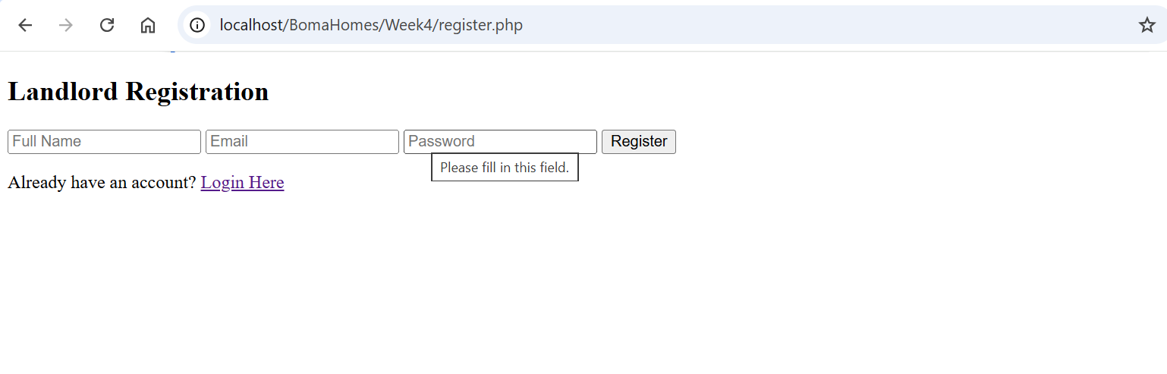
Fig 4.1 shows the landlord registration form used for account creation in the BomaHomes system
Login Form
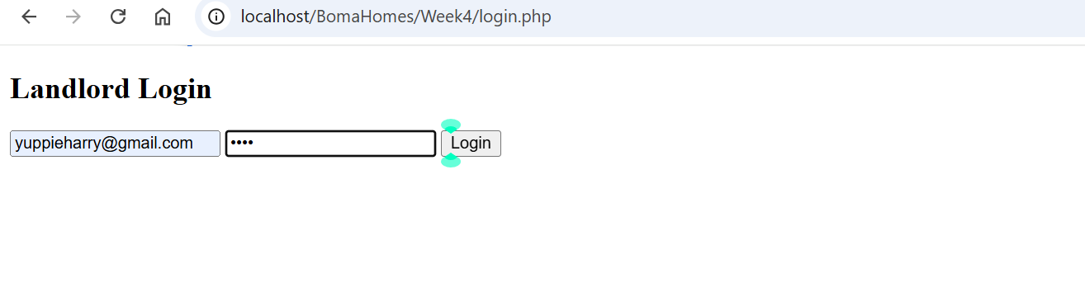
Fig4.2 shows the landlord login page developed using PHP and HTML forms.
Successful login dashboard
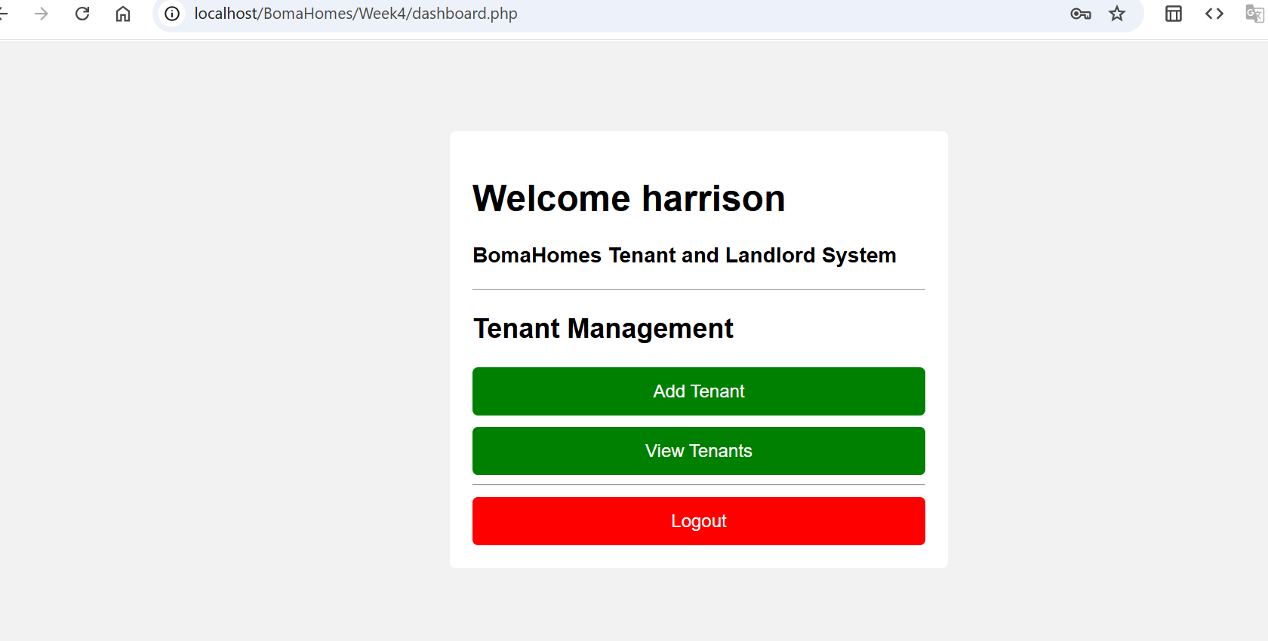
Fig 4.3 shows successful authentication and access to the BomaHomes dashboard.

Session Handling Test
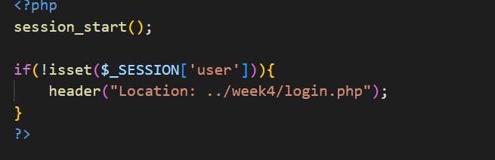
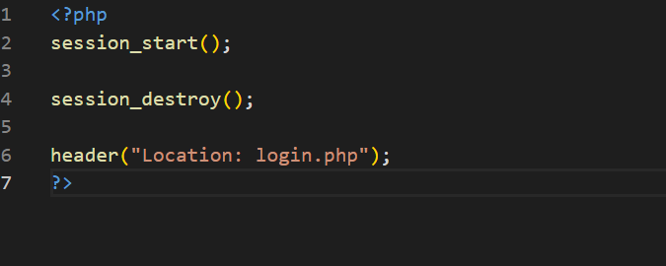
Fig 4.4 shows session management functionality used to protect dashboard access.

Week 5
Database Integration and CRUD Operations

Objectives
The objective of Week 5 was to integrate MySQL database operations into the BomaHomes system and implement CRUD functionality.

Activities
During this week, the following activities were completed:
- Created tenant database table
- Developed add tenant functionality
- Retrieved tenant records from database
- Implemented update functionality
- Implemented delete functionality
- Connected frontend forms to MySQL database

Student Reflection
During Week 5, I implemented CRUD operations for the BomaHomes Tenant and Landlord Management System. PHP and MySQL were integrated to allow adding, viewing, updating, and deleting tenant records dynamically. This week improved my understanding of backend-data integration and database-driven web applications.

Figures

Tenant Registration Form
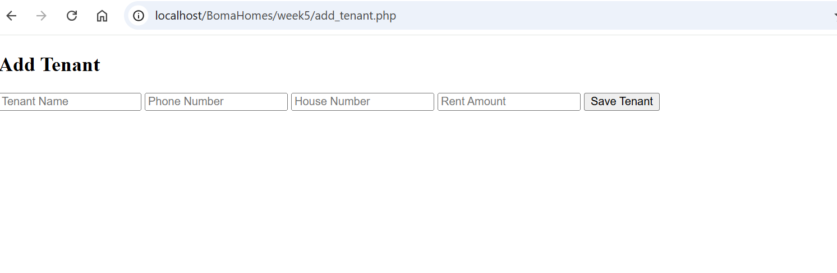
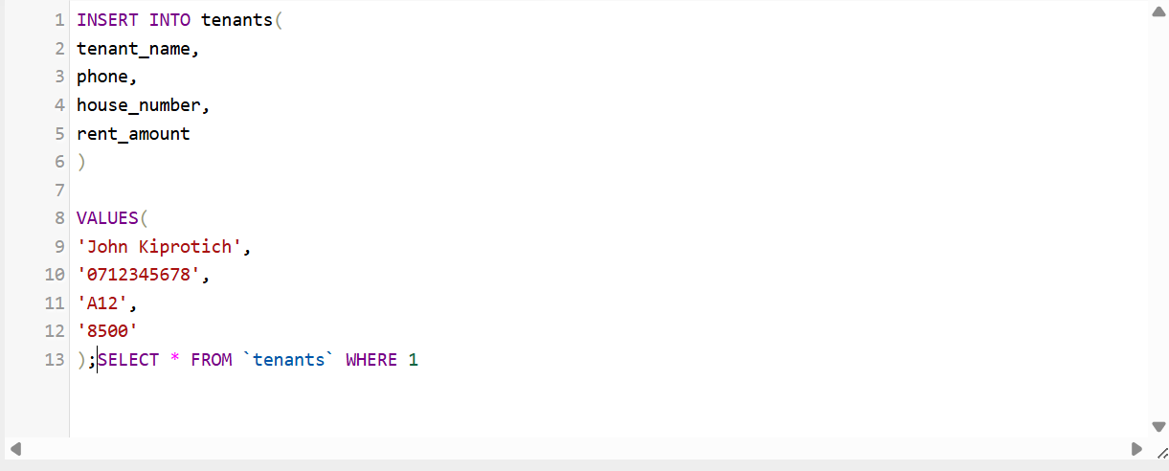
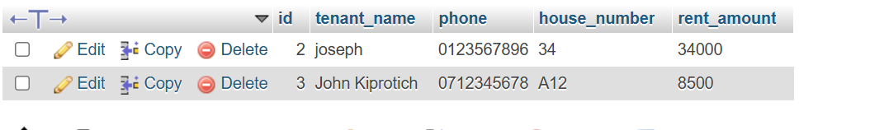
Fig5.1 shows the form used to add tenant records into the BomaHomes database.

Viewing Tenants Records

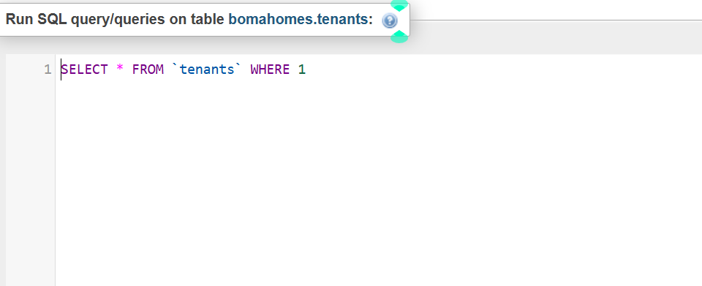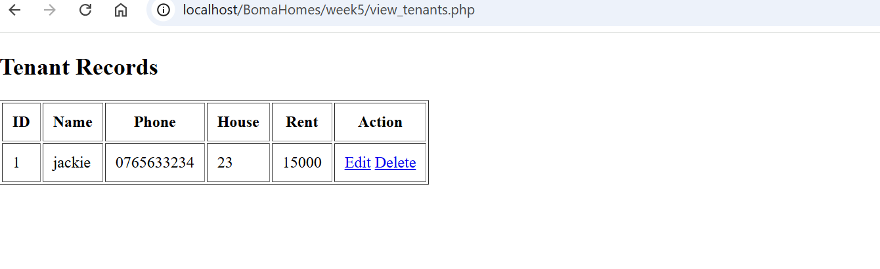
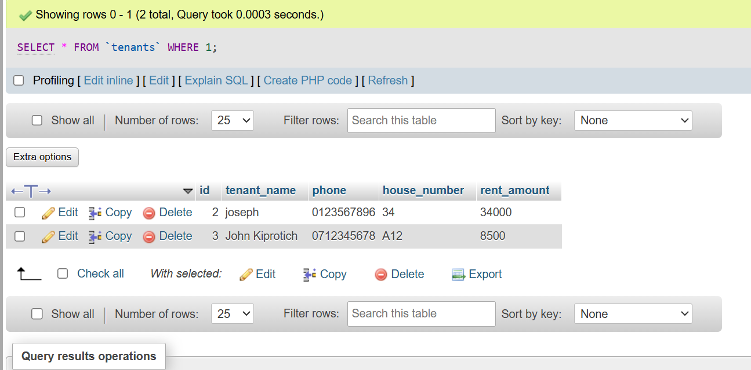

Fig 5.2 shows retrieval and display of tenant records from the MySQL database

Updating Tenant Information
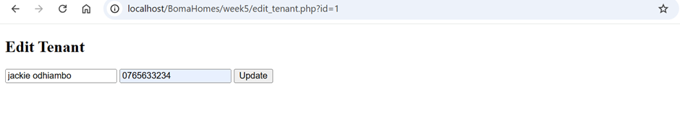
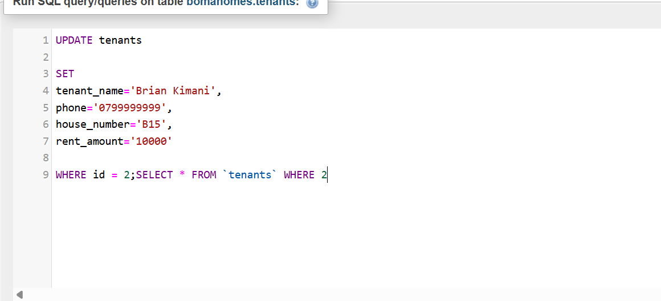
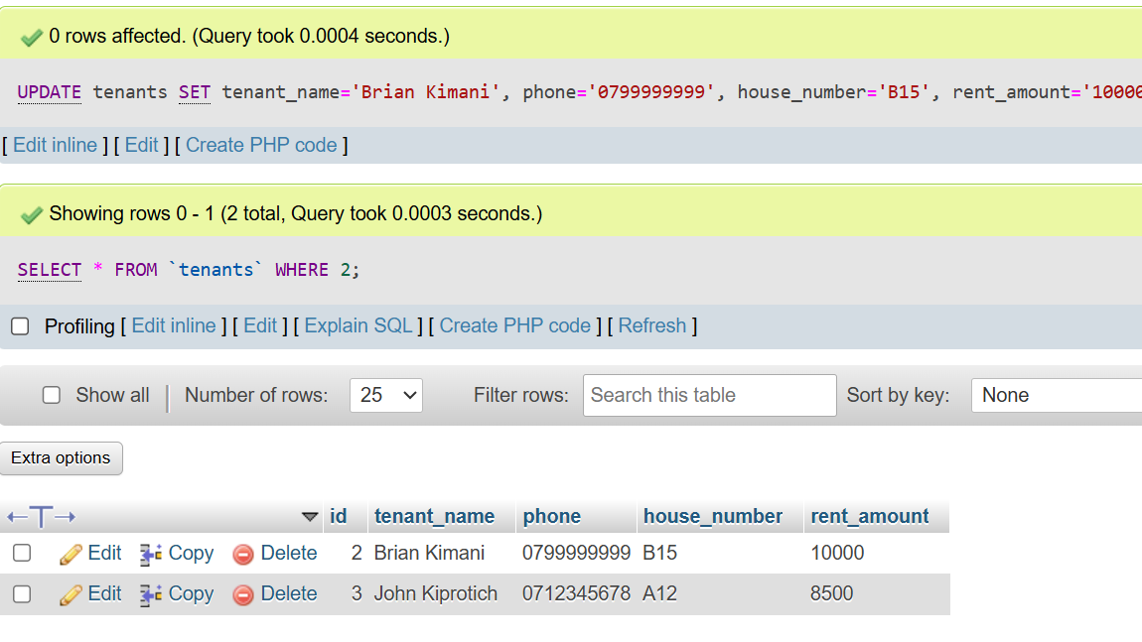
Fig 5.3 shows editing and updating tenant information using PHP and MySQL.

Deleting Tenant Records
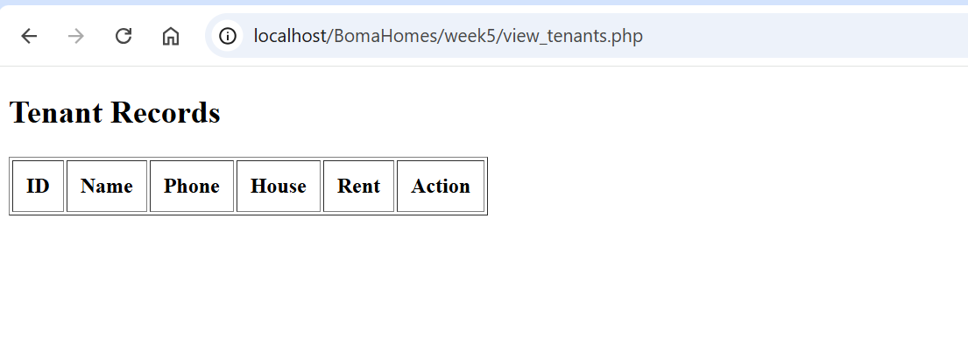
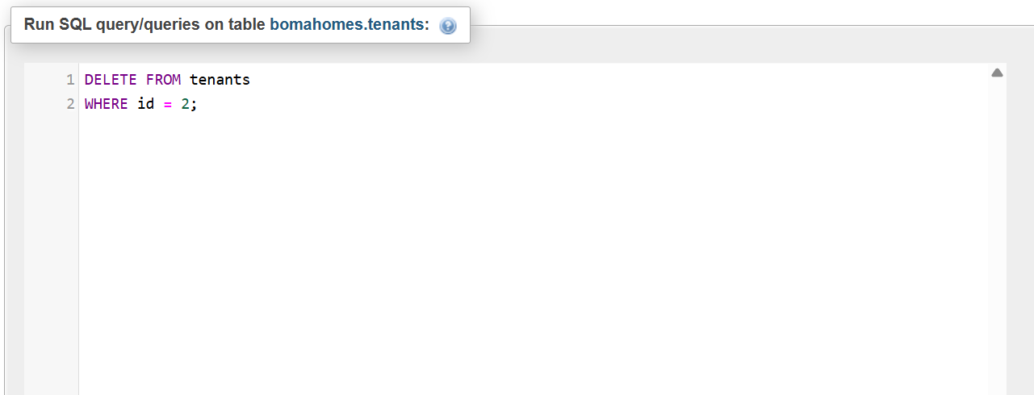
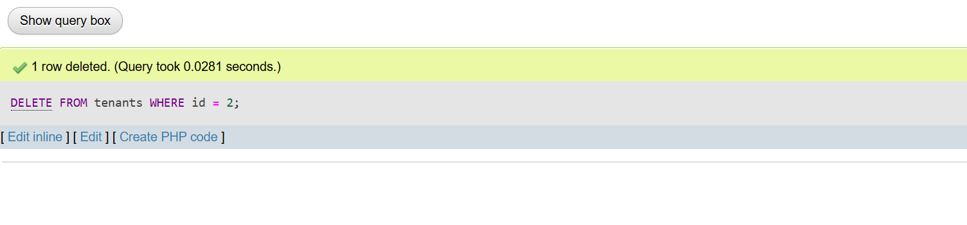
Fig 5.4 shows deletion of tenant records from the database.

MySQL database tables
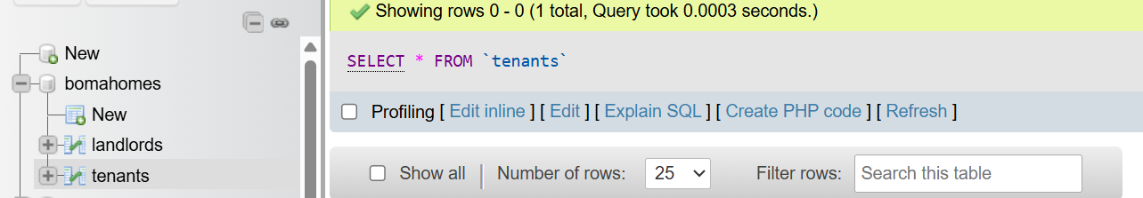
Fig 5.5 shows database tables created in phpMyAdmin for the BomaHomes system.

